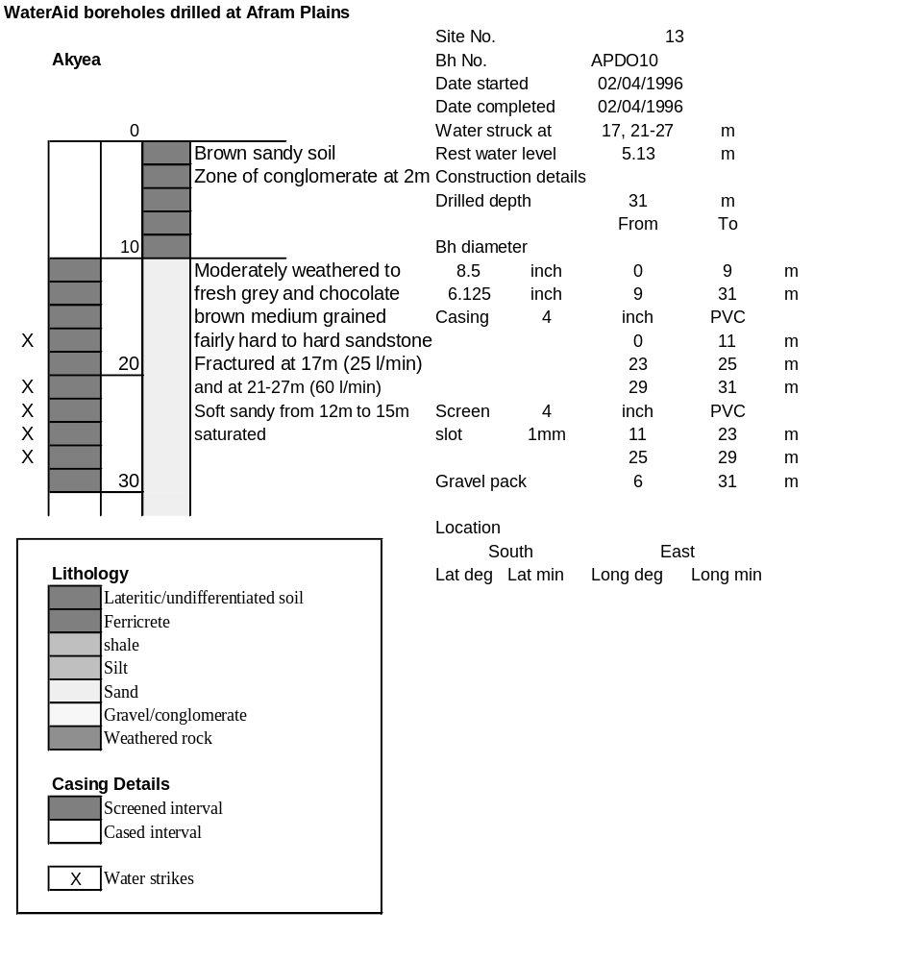

Ghana | Test pumping
Borehole No. |  | APDO10
Hole No |  | 13
Village |  | Akyea
Date |  | 18/04/1996
Point above GL |  | 0.5 | m
Pump depth |  | 24 | m
SWL |  | 5.63 | m
Start Time |  | 07:25
Drawdown test |  |  |  |  | Recovery test
time | pwl (m) | Q l/min | dd | sc | Time | wl (m) | s' | t/t'
0.00 | 5.63 | 50.00 | 0.00 |  | 0.00 | 14.70 | 9.07
1.00 | 8.63 | 50.00 | 3.00 | 16.67 | 1.00 | 7.72 | 2.09 | 181.00
2.00 | 9.00 | 50.00 | 3.37 | 14.84 | 2.00 | 6.04 | 0.41 | 91.00
3.00 | 9.68 | 50.00 | 4.05 | 12.35 | 3.00 | 5.95 | 0.32 | 61.00
4.00 | 9.89 | 50.00 | 4.26 | 11.74 | 4.00 | 5.92 | 0.29 | 46.00
5.00 | 10.05 | 50.00 | 4.42 | 11.31 | 5.00 | 5.90 | 0.27 | 37.00
6.00 | 10.28 | 50.00 | 4.65 | 10.75 | 6.00 | 5.90 | 0.27 | 31.00
7.00 | 10.48 | 50.00 | 4.85 | 10.31 | 7.00 | 5.89 | 0.26 | 26.71
8.00 | 10.65 | 50.00 | 5.02 | 9.96 | 8.00 | 5.88 | 0.25 | 23.50
9.00 | 10.89 | 50.00 | 5.26 | 9.51 | 9.00 | 5.87 | 0.24 | 21.00
10.00 | 11.09 | 50.00 | 5.46 | 9.16 | 10.00 | 5.87 | 0.24 | 19.00
11.00 | 11.23 | 50.00 | 5.60 | 8.93 | 12.00 | 5.86 | 0.23 | 16.00
12.00 | 11.40 | 50.00 | 5.77 | 8.67 | 14.00 | 5.86 | 0.23 | 13.86
13.00 | 11.51 | 50.00 | 5.88 | 8.50 | 16.00 | 5.85 | 0.22 | 12.25
14.00 | 11.70 | 50.00 | 6.07 | 8.24 | 18.00 | 5.85 | 0.22 | 11.00
15.00 | 11.84 | 50.00 | 6.21 | 8.05 | 20.00 | 5.84 | 0.21 | 10.00
16.00 | 11.97 | 50.00 | 6.34 | 7.89 | 22.00 | 5.83 | 0.20 | 9.18
17.00 | 12.09 | 50.00 | 6.46 | 7.74 | 24.00 | 5.83 | 0.20 | 8.50
18.00 | 12.20 | 50.00 | 6.57 | 7.61 | 26.00 | 5.83 | 0.20 | 7.92
19.00 | 12.30 | 50.00 | 6.67 | 7.50 | 28.00 | 5.83 | 0.20 | 7.43
20.00 | 12.39 | 50.00 | 6.76 | 7.40 | 30.00 | 5.82 | 0.19 | 7.00
22.00 | 12.54 | 50.00 | 6.91 | 7.24 | 35.00 | 5.81 | 0.18 | 6.14
24.00 | 12.67 | 50.00 | 7.04 | 7.10 | 40.00 | 5.81 | 0.18 | 5.50
26.00 | 12.84 | 50.00 | 7.21 | 6.93 | 45.00 | 5.80 | 0.17 | 5.00
28.00 | 12.97 | 50.00 | 7.34 | 6.81 | 50.00 | 5.79 | 0.16 | 4.60
30.00 | 13.09 | 50.00 | 7.46 | 6.70 | 60.00 | 5.78 | 0.15 | 4.00
35.00 | 13.29 | 50.00 | 7.66 | 6.53 | 70.00 | 5.78 | 0.15 | 3.57
40.00 | 13.46 | 50.00 | 7.83 | 6.39 | 80.00 | 5.77 | 0.14 | 3.25
45.00 | 13.61 | 50.00 | 7.98 | 6.27 | 90.00 | 5.77 | 0.14 | 3.00
50.00 | 13.70 | 50.00 | 8.07 | 6.20 | 100.00 | 5.77 | 0.14 | 2.80
55.00 | 13.79 | 50.00 | 8.16 | 6.13 | 110.00 | 5.77 | 0.14 | 2.64
60.00 | 13.85 | 50.00 | 8.22 | 6.08 | 120.00 | 5.77 | 0.14 | 2.50
70.00 | 13.94 | 50.00 | 8.31 | 6.02
80.00 | 14.04 | 50.00 | 8.41 | 5.95
90.00 | 14.15 | 50.00 | 8.52 | 5.87
100.00 | 14.25 | 50.00 | 8.62 | 5.80
110.00 | 14.33 | 50.00 | 8.70 | 5.75
120.00 | 14.41 | 50.00 | 8.78 | 5.69
130.00 | 14.46 | 50.00 | 8.83 | 5.66
140.00 | 14.52 | 50.00 | 8.89 | 5.62
160.00 | 14.62 | 50.00 | 8.99 | 5.56
180.00 | 14.70 | 50.00 | 9.07 | 5.51

